Cultiv8 Tennis

Safeguarding Policy



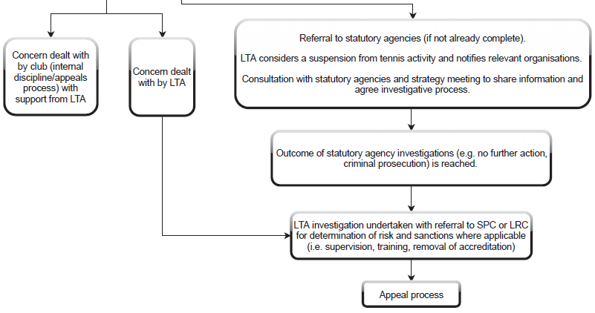
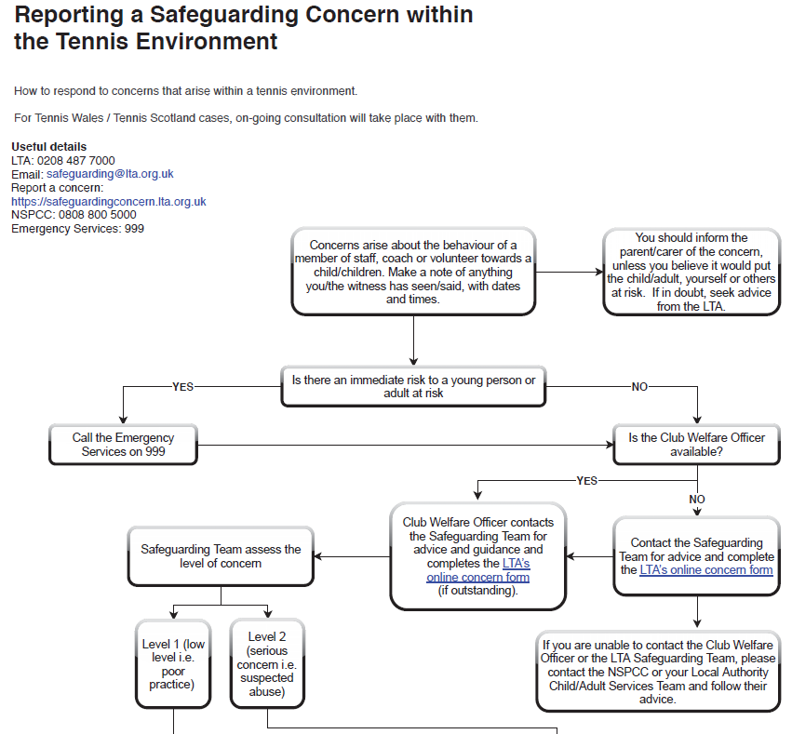
SPC = Safeguarding and Protection Committee
LRC = Licensing and Registration Committee
Safeguarding Policy

- Policy statement

Cultiv8 Tennis is committed to prioritising the well-being of all children and adults at risk, promoting safeguarding in our club at all times, including all programmes and events we run. All activities, events and trips arranged by the club run in accordance with the LTA’s Safeguarding at Events and Competitions guidance. This Policy strives to minimise risk, deliver a positive tennis experience for everyone and respond appropriately to all safeguarding concerns/disclosures.
- Use of terminology

Child: a person under the age of eighteen years.

Note that some legislation in Scotland defines a child as a person under sixteen years old. However, where there is any safeguarding concern, anyone under the age of 18 is regarded as a child unless advised otherwise by the LTA Safeguarding Team .

Adult at risk: a person aged eighteen years or over who is, or may be, in need of community care services by reason of disability, age or illness; and is, or may be, unable to take care of, or unable to protect him or herself against abuse or neglect.

Safeguarding children: protecting children from abuse and neglect, preventing the impairment of children’s health or development, ensuring that they grow up in circumstances consistent with the provision of safe and effective care, and taking action to enable all children to have the best life chances.

Safeguarding adults at risk: protecting adults from abuse and/or neglect. Enabling adults to maintain control over their lives and make informed choices without coercion. Empowering adults at risk, consulting them before taking action, unless someone lacks the capacity to make a decision, or their mental health poses a risk to their own or someone else’s safety, in which case, always acting in his or her best interests.

(See appendix A for full glossary of terms).

- Scope

This Policy is applicable to all staff, volunteers, the committee, coaches and club members. It is in line with national legislation and applicable across the UK.

Advice, guidance and support is available from the LTA Safeguarding Team.

- Responsibility for the implementation of the Safeguarding Policy, Code of Conduct and Reporting Procedure

SAFEGUARDING IS EVERYONE’S RESPONSIBILITY: NOT RESPONDING TO A SAFEGUARDING CONCERN IS NOT AN OPTION.

- Our Company’s Management have overall accountability for this Policy and its implementation
- Our Programme Manager, Laura Crabtree is responsible for updating this Policy in line with legislative and club developments.
- All individuals involved in / present at the club are required to adhere to the Policy and Code of Conduct
- The LTA Safeguarding Team and Tennis Scotland, Tennis Wales and Tennis Foundation Safeguarding Leads can offer support to help clubs proactively safeguard.

Where there is a safeguarding concern/disclosure:
- The individual who is told about, hears, or is made aware of the concern/disclosure is responsible for following the Reporting a Safeguarding Concern Procedure shown in the flowchart at the beginning of this policy. Unless someone is in immediate danger, they should inform their County Welfare Officer, County Safeguarding Officer, LTA Safeguarding Team or National Safeguarding Lead.
- The County Safeguarding Officer and Safeguarding Leads are responsible for reporting safeguarding concerns to the LTA Safe Safeguarding Team.
- The LTA Safeguarding Team is responsible for assessing all safeguarding concern/disclosures that are reported to them and working with the club Welfare Officer and National Safeguarding Leads to follow up as appropriate on a case-by-case basis, prioritising the well-being of the child/ adult at risk at all times. Dependent on the concern/disclosure, a referral may be made to:

- The police in an emergency (999);
- Leeds Children’s Services - Kernel House, Killingbeck Dr, Leeds LS14 6UF Phone: 0113 222 4403
- Leeds Adult Services - Merrion House, Leeds, LS2 8QB. Tel: 0113 247 8577
- LTA Safeguarding Team – safeguarding@lta.org.uk
- Yorkshire Tennis Safeguarding Team – safeguarding.yorkshiretennis@gmail.com
- Local Authority Designated Officer for concerns / disclosures about a member of staff, consultant, coach, official or volunteer – LADO@leeds.gov.uk / 0113 378 9687

- Breaches of the Safeguarding Policy, Code of Conduct and Reporting Procedure

Breaches of this Policy and/or failure to comply with the outlined responsibilities may result in the following:
- Disciplinary action leading to possible exclusion from the club, dismissal and legal action
- Termination of current and future roles within the club and roles in other clubs, the LTA, Tennis Wales, Tennis Scotland and the Tennis Foundation.

Actions taken by players, parents or carers, staff, consultants, volunteers, officials, coaches inside or outside of the club that are seen to contradict this Policy may be considered a violation of this Policy.

- Whistleblowing

Safeguarding children and adults at risk requires everyone to be committed to the highest possible standards of openness, integrity and accountability. As a club, we are committed to encouraging and maintaining a culture where people feel able to raise a genuine safeguarding concern and are confident that it will be taken seriously.

What is whistle blowing?
In the context of safeguarding, “whistle blowing” is when someone raises a concern about the well-being of a child or an adult at risk.

A whistle blower may be:
- a player;
- a volunteer;
- a coach;
- other member of staff;
- an official;
- a parent;
- a member of the public.

How to raise a concern about a child or an adult at risk at the club
If a child or an adult at risk is in immediate danger or risk of harm, the police should be contacted by calling 999.

Where a child or an adult at risk is not in immediate danger, any concerns about their well-being should be made without delay to the Club Welfare Officer. The Club Welfare Officer will pass the details of the concern on to the LTA Safeguarding Team at the earliest opportunity and the relevant local authority and the police will be contacted, where appropriate.

If, however, the whistle blower does not feel comfortable raising a concern with the Club Welfare Officer, the whistle blower should contact the LTA Safeguarding Team directly on 020 8487 7000, the Local Authority Designated Officer (LADO) on lado@leeds.gov.uk / 0113 37 89687 or the NSPCC on 0808 800 5000. The County Safeguarding Officer, Karen Mitchell can be contacted on 01226 107092 / safeguarding.yorkshiretennis@gmail.com

Information to include when raising a concern
The whistle blower should provide as much information as possible regarding the incident or circumstance which has given rise to the concern, including:
- their name and contact details (unless they wish to remain anonymous);
- names of individuals involved;
- date, time and location of incident/circumstance; and
- whether any witnesses were present.

What happens next?
All concerns raised by a whistle blower about the well-being of a child or an adult at risk will be taken seriously and every effort will be made to deal with each concern fairly, quickly and proportionately.

If the whistle blower does not believe that the concern has been dealt with appropriately and wishes to speak to someone outside the club or the LTA Safeguarding Team, the NSPCC Whistleblowing advice line should be contacted on 0800 028 0285 or by emailing help@nspcc.org.uk.

Support
The club will not tolerate any harassment, victimisation or unfair treatment of, and will take appropriate action to protect, whistle blowers when they raise a concern in good faith.

Codes of Conduct

All members of staff, volunteers and members agree to:
- Prioritise the well-being of all children and adults at risk at all times
- Treat all children and adults at risk fairly and with respect
- Be a positive role model. Act with integrity, even when no one is looking
- Help to create a safe and inclusive environment both on and off court
- Not allow any rough or dangerous behaviour, bullying or the use of bad or inappropriate language
- Report all allegations of abuse or poor practice to the club Welfare Officer
- Not use any sanctions that humiliate or harm a child or adult at risk
- Value and celebrate diversity and make all reasonable efforts to meet individual needs
- Keep clear boundaries between professional and personal life, including on social media
- Have the relevant consent from parents/carers, children and adults before taking or using photos and videos
- Refrain from making physical contact with children or adults unless it is necessary as part of an emergency or congratulatory (e.g. handshake / high five)
- Refrain from smoking and consuming alcohol during club activities or coaching sessions
- Ensure roles and responsibilities are clearly outlined and everyone has the required information and training
- Avoid being alone with a child or adult at risk unless there are exceptional circumstances
- Refrain from transporting children or adults at risk, unless this is required as part of a club activity (e.g. away match) and there is another adult in the vehicle
- Not abuse, neglect, harm or discriminate against anyone; or act in a way that may be interpreted as such
- Not have a relationship with anyone under 18 for whom they are coaching or responsible for
- Be acutely aware of the power that coaches and coaching assistants develop over players in the coaching relationship and avoid any intimacy (sexual or otherwise) with players

All children agree to:
- Be friendly, supportive and welcoming to other children and adults
- Play fairly and honestly
- Respect club staff, volunteers and Officials and accept their decisions
- Behave, respect and listen to your coach
- Take care of your equipment and club property
- Respect the rights, dignity and worth of all participants regardless of age, gender, ability, race, culture, religion or sexual identity
- Not use bad, inappropriate or racist language, including on social media
- Not bully, intimidate or harass anyone, including on social media
- Not smoke, drink alcohol or drugs of any kind on club premises or whilst representing the club at competitions or events
- Talk to the County Welfare / Safeguarding Officer about any concerns or worries they have about themselves or others

All parents and carers agree to:
- Positively reinforce your child and show an interest in their tennis
- Use appropriate language at all times
- Be realistic and supportive
- Never ridicule or admonish a child for making a mistake or losing a match
- Treat all children, adults, volunteers, coaches, officials and members of staff with respect
- Behave responsibly at the venue; do not embarrass your child
- Accept the official’s decisions and do not go on court or interfere with matches
- Encourage your child to play by the rules, and teach them that they can only do their best
- Deliver and collect your child punctually from the venue
- Ensure your child has appropriate clothing for the weather conditions
- Ensure that your child understands their code of conduct
- Adhere to your venue’s safeguarding policy, diversity and inclusion policy, rules and regulations
- Provide emergency contact details and any relevant information about your child including medical history

This Policy is reviewed every two years (or earlier if there is a change in national legislation).

This Policy is recommended for approval by:

Programme Manager at Cultiv8 Tennis: Laura Crabtree Date: 07/09/2020

County Safeguarding Officer: Karen Mitchell Date: 07/09/2020

Appendix A: Glossary of Terms

Safeguarding: protecting children from abuse and neglect, preventing the impairment of children’s health or development, ensuring that children are growing up in circumstances consistent with the provision of safe and effective care, and taking action to enable all children to have the best life chances. Enabling adults at risk to achieve the outcomes that matter to them in their life; protecting their right to live in safety, free from abuse and neglect. Empowering and supporting them to make choices, stay safe and raise any concerns. Beginning with the assumption that an individual is best-placed to make decisions about their own wellbeing, taking proportional action on their behalf only if someone lacks the capacity to make a decision, they are exposed to a life-threatening risk, someone else may be at risk of harm, or a criminal offence has been committed or is likely to be committed.

Abuse and neglect

Physical abuse: A form of abuse which may involve hitting, shaking, throwing, poisoning, burning or scalding, drowning, suffocating or otherwise causing physical harm to a child or adult at risk. Physical harm may also be caused when a parent or carer fabricates the symptoms of, or deliberately induces illness

Sexual abuse: Involves forcing or enticing a child or young person to take part in abuse sexual activities, not necessarily involving a high level of violence, whether or not the child is aware of what is happening. The activities may involve physical contact, including assault by penetration (for example, rape or oral sex) or non-penetrative acts such as masturbation, kissing, rubbing and touching outside of clothing. They may also include non-contact activities, such as involving children in looking at, or in the production of, sexual images, watching sexual activities, encouraging children to behave in sexually inappropriate ways, or grooming a child in preparation for abuse (including via the internet). Sexual abuse is not solely perpetrated by adult males. Women can also commit acts of sexual abuse, as can other children

Emotional abuse: The persistent emotional maltreatment of a child or adult at risk such as to cause severe and persistent adverse effects on their emotional development. It may involve conveying to a child/ adult at risk that they are worthless or unloved, inadequate, or valued only insofar as they meet the needs of another person; not giving them opportunities to express their views; deliberately silencing them or ‘making fun’ of what they say or how they communicate. It may feature age or developmentally inappropriate expectations being imposed, including interactions that are beyond a child or adult at risk’s developmental capability, as well as overprotection and limitation of exploration and learning, or preventing them participating in normal social interaction. It may involve seeing or hearing the ill-treatment of another. It may involve serious bullying (including cyber bullying), causing a child or adult at risk to feel frightened or in danger, or the exploitation or corruption of children. Some level of emotional abuse is involved in all types of maltreatment of a child, though it may occur alone.

Neglect: The persistent failure to meet a child/ adult at risk’s basic physical and/or psychological needs, likely to result in the serious impairment of their health or development. It may involve a parent or carer failing to:
provide adequate food, clothing and shelter (including exclusion from home or abandonment);
protect a child/ adult at risk from physical and emotional harm or danger;
ensure adequate supervision (including the use of inadequate care-givers); or
ensure access to appropriate medical care or treatment.
It may also include neglect of, or unresponsiveness to, a child’s or adult at risk’s basic emotional needs. Neglect may occur during pregnancy as a result of maternal substance abuse.

Additional examples of abuse and neglect of adults at risk

Financial abuse: having money or property stolen; being defrauded; being put under pressure in relation to money or other property; and having money or other property misused.
Discriminatory abuse: treating someone in a less favourable way and causing them harm, because of their age, gender, sexuality, gender identity, disability, socio-economic status, ethnic origin, religion and any other visible or non-visible difference.
Domestic abuse: includes physical, sexual, psychological or financial abuse by someone who is, or has been a partner or family member. Includes forced marriage, female genital mutilation and honour-based violence (an act of violence based on the belief that the person has brought shame on their family or culture). Domestic abuse does not necessarily involve physical contact or violence.
Psychological abuse: including emotional abuse, threats of harm or abandonment, deprivation of contact, humiliation, blaming, controlling, intimidation, coercion, harassment, verbal abuse, isolation or withdrawal from services or supportive networks.

Organisational abuse: where the needs of an individual are not met by an organisation due to a culture of poor practice or abusive behaviour within the organisation.

Self-neglect: behaviour which threatens an adult’s personal health or safety (but not that of others). Includes an adult’s decision to not provide themselves with adequate food, clothing, shelter, personal hygiene, or medication (when indicated), or take appropriate safety precautions
Modern slavery: encompasses slavery, human trafficking, criminal and sexual exploitation, forced labour and domestic servitude. Traffickers and slave masters use whatever means they have at their disposal to coerce, deceive and force individuals into a life of abuse, servitude and inhumane treatment.

A person who is being abused may experience more than one type of abuse
Harassment, and bullying are also abusive and can be harmful
Female Genital Mutilation (FGM) is now recognised as a form of physical, sexual and emotional abuse that is practised across the UK
Child Sexual Exploitation is recognised as a form of sexual abuse in which children are sexually exploited for money, power or status
Child trafficking is recognised as child abuse where children are often subject to multiple forms of exploitation. Children are recruited, moved or transported to, or within the UK, then exploited, forced to work or sold
People from all cultures are subject to abuse. It cannot be condoned for religious or cultural reasons
Abuse can have immediate and long-term impacts on someone’s well-being, including anxiety, depression, substance misuse, eating disorders and self-destructive Conducts, offending and anti-social Conduct
Those committing abuse are most often adults, both male and female. However, child-to-child abuse also takes place.

Appendix B: What to do if a disclosure from a child or adult at risk is made to you:

- Listen carefully and calmly to the individual
- Reassure the individual that they have done the right thing and what they have told you is very important
- Avoid questioning where possible, and never ask leading questions
- Do not promise secrecy. Let the individual know that you will need to speak to the Welfare Officer/LTA Safeguarding Team because it is in their best interest. If you intend to speak to the police or social care, you should let them know this too.
- Report the concern. In an emergency, call the police (999), otherwise talk to the Welfare Officer/LTA Safeguarding Team as soon as possible. Do not let doubt/personal bias prevent you from reporting the allegation
- Record details of the disclosure and allegation using the LTA’s online reporting a concern form within 24 hours. If you do not have access to the online form, write down the details using what you have available then sign and date it.

Appendix C

